**Executive Summary**

**The Problem:**

Adidas’s business weaknesses are caused by disparities in profit across regions and retailers. Most notably, there is a $20 million revenue difference between men's and women's footwear, and a large range of operational performance across all retailers. Along with this, price sensitivity issues and operational costs are leading to lower sales across all regions. To remedy these weaknesses, we aim to utilize data-driven insights to find effective solutions for Adidas.

**The Solution:**

Focused marketing and promotional initiatives are necessary to balance product performance within the company. The significance of increasing unit sales is highlighted by the strong relationship between operating profit and sales volume, especially in high-performing categories like Men's Street Footwear.

The performance of retailers varies greatly, with Sports Direct and West Gear making the most profit. It's critical to maximize collaborations and deal with poor performance in stores like Walmart, to achieve sales similar to Sports Direct and West Gear. Even though Adidas has high operating margins, profitability can be further increased by ongoing efforts to cut expenses and boost operational effectiveness.

The analysis of Adidas sales and profitability data reveals several key trends and opportunities for improvement. Firstly, sales volume across product categories remained stable through 2020, but there was a sharp increase post-COVID-19 with a significant 20 million gap between Women’s and Men’s athletic footwear in 2021. Generally, operating margins are very strong, with a median of 0.41, however, some categories, particularly Women’s Apparel, show some variability. To optimize profitability, Adidas should focus on improving operational efficiency, refining pricing strategies, and exploring partnerships with high-performing retailers, while addressing the challenges in lower-performing regions.

**Introduction**

Adidas, a global sports and lifestyle brand, was founded in 1924 by Adi Dassler in Germany (Herzogenaurach, n.d.). Known for its innovative products and iconic branding, the company has consistently pushed the boundaries of athletic performance and style.

The year 2020 presented significant challenges due to the COVID-19 pandemic. Global lockdowns, supply chain disruptions, and decreased consumer spending led to a 14% decline in net sales and a significant drop in operating and net income. 2021 marked a year of recovery for Adidas as the global economy began to rebound from the pandemic. Net sales increased by 16% to €21.2 billion, driven by strong growth in e-commerce and key markets like North America and China. Gross margin improved to 50.7%, and operating profit surged to €1.492 billion, a significant increase from the previous year (History - Adidas Group, n.d.).

In the first half of 2024, the company achieved a gross margin of 51.0%, a significant improvement from 47.9% in 2023. Operating profit surged to €682 million in 2024, a substantial increase from €236 million in 2023. Net income also grew to €382 million in 2024, up from €73 million in 2023.

Adidas is focused on identifying its business's least profitable areas to uncover growth and optimization opportunities. By analyzing sales data, the company aims to uncover correlations and gain insights into consumer behavior, including purchasing patterns, preferences, and regional market dynamics. These insights are intended to inform targeted strategies that optimize operations, enhance customer engagement, and increase revenue performance based on geographic location. The initiative seeks to align business efforts with consumer needs while maximizing profitability across all regions.

We are focusing on one main area: How can Adidas optimize its profitability across different locations by leveraging sales data, consumer behavior insights, and regional market dynamics.

Our objective for this paper is to identify profitability gaps across regions, determine which regions generate the most amount of revenue along with the factors contributing to their success, and identify which product is the main driver for revenue

**Discussion of the data available**

This original dataset provides detailed information on various aspects of Adidas sales transactions. This dataset includes categorical variables such as region, state, city, product, invoice date, and retailer ID, and numerical variables such as price per unit, units sold, total sales, operating profit, operating margin, and sales method. Appendix 1 showcases the different variables from the original dataset file alongside a brief description of each variable.

**Cleaning the data**

Before analyzing the data, we had to clean the data. Firstly, there was a logo image on the excel file, causing import errors. The image disrupted the data structure, leading to misalignment and parsing issues within Tableau. To resolve this, we removed the logo and ensured the data was properly formatted. Next, in order to get a map, we needed to get the longitude and latitude values per state. By utilizing python, and the combine.py python file, we added 2 rows called longitude and latitude based on state. We managed to create the 2 columns by checking if the states column in the US Sales Dataset equaled to the state name of the states dataset. Next, for our 2 sample test, we wanted to filter which products are “Mens” and “Womens”, and create a new column called “Men” and “Women” through excel to categorize them accordingly.

**Presentation of Results**

**Sales Trends By Product Category**

Sales over time has been graphed by product category to understand sales trends and consumer behaviour (Appendix 3). The results of this analysis will inform us on the types of products that are contributing to our sales, and possibly, what products are struggling compared to others. The graph shows that all of the product categories carried a relatively stable and small range of sales volume, from Q1 2020 to Q4 of that same year. After that point, there is a sharp increase in sales volume across all product categories, a main contributing factor to this would be the change in consumer behaviour after COVID-19. The main takeaway from this graph is the disparity in sales volume between Women's Athletic Footwear and Men’s street footwear. As of Q4 2021, there is a $20 million dollar difference in sales volume between product categories. Compared to sales volume in 2020, the range of our sales has increased drastically from roughly $4 million dollars to $20 million dollars. In order to decrease the range of sales volume between our product categories, we should refocus our marketing efforts towards our Women’s Athletic footwear. This will result in increased sales volume in this product category, leading to more reliable sales overall. The two categories were consistent with one another in 2020, so we should aim to decrease the range while maintaining a high value for sales volume to create more reliability for Adidas’s sales.

**Box Plot: Outliers in terms of Profitability**

The following Box Plot showcases the median and its trends for the data’s operating margin (Appendix 4). The median of operating margin 0.4100, with 50% of Operating Margins are from 0.3500 - 0.4900. With the whisker range being from 0.1500 - 0.6900. The outlier with the very low operating margin is a Women's Apparel with 0.1200 and 0.100. However the outliers with very high operating margins are still Women’s Apparel of 0.800 with other Men’s Apparel in the outliers as well. The presence of many outliers above the upper whisker suggests a positive skew, with the data tailing off toward higher operating margins.

The results convey that although having a median operating margin of 0.4100 is a good operating margin. An operating margin of 41% means that for every dollar of revenue, the company keeps $0.41 as operating income after covering operating expenses. It is especially encouraging to have a positive skew with many outliers above the upper whisker meaning there is potential to move the median of operating margin with cost rearrangement and retailer reconsiderations. In order to understand what the operating margin means for adidas, the industry average for operating margin is 11.47%. According to *Apparel, footwear & accessories industry profitability*. In comparison to industry standards, Adidas should not be too concerned with its operating margins. However, reducing costs to improve margins would always be recommended.

**Correlation Matrix: Highlighting Important Relationships**

The correlation matrix heatmap for Adidas sales data provides valuable insights into the relationships between key business metrics (Appendix 5). The color scale, ranging from -1 (dark blue) to 1 (dark red), represents the strength and direction of correlations. Values close to 1 indicate a strong positive relationship, where one variable increases alongside the other, while values near -1 suggest a strong negative relationship, where one variable increases as the other decreases. Correlations near 0 imply no significant relationship. It can be observed that Total Sales and Operating Profit are highly correlated (0.96), reflecting that increased revenue translates significantly to profitability. Moderate positive relationships are observed between Price per Unit and Total Sales (0.44) and Price per Unit and Operating Profit (0.39), suggesting a limited yet positive impact of pricing on revenue and profit. Conversely, weak negative correlations are seen with Operating Margin and variables like Units Sold (-0.31) and Total Sales (-0.36), potentially signaling that higher sales volumes or revenues might slightly reduce margins due to increased costs.

The analysis highlights several strategic considerations for Adidas. First, focusing on unit sales is critical, as it strongly influences both Total Sales and Operating Profit. This suggests that initiatives to boost sales volume, such as targeted marketing campaigns or expanded distribution, could significantly improve profitability. Second, the weaker correlation between Price per Unit and Operating Profit indicates that pricing adjustments alone may not substantially enhance profits, implying that Adidas should balance pricing strategies with other operational efficiencies. Finally, the negative correlations involving Operating Margin suggest an opportunity to improve efficiency. By optimizing cost structures and streamlining operations, Adidas could enhance profitability without solely relying on increasing sales or revenue. This balanced approach could ensure sustainable growth across key financial metrics.

**Bar Chart: Units sold and Profit generated by each Retailer**

The bar chart below illustrates the operating profit and units sold generated by Adidas retailers (Appendix 6). The data reveals trends across retailers, with West Gear leading in both units sold and profitability with Walmart being the least profitable retailer and Amazon having the least units sold. This suggests that Amazon is more profitable than Walmart even though it sells less units. Walmart is an outlier of the trend of the more units sold the more profit a retailer provides. There is a noticeable difference between the total units sold figures and operating profit, with greater variations among the top three revenue earners—Sports Direct, Foot Locker, and West Gear—compared to their units sold figures. For example, while Sports Direct's units are 10% lower than West Gear's, its operating profit is 13% lower. This suggests a narrower range of units sold among the top three retailers in comparison to the profit range.

In order to optimize profitability Adidas should research why retailers like Walmart, Amazon, Kohl’s are not performing as well as Sports Direct, Foot Locker, and West Gear. Additionally, due to great differences between profit and sales, decreasing costs would be recommended. Furthermore targeting Sports Direct, Foot Locker, West Gear for selling more adidas products instead of Walmart, Amazon, Kohl’s. Final recommendation per unit in comparison to the other three low profitable retailers.

**Stacked Bar Chart: Breakdown of Product Type by Retailer**

The following chart showcases the percentage of operating profit per product for each retailer (Appendix 7). The following focuses specifically on the male apparel. The results demonstrate that product popularity is similar among all retailers with Men’s Street Footwear being the most profitable. Men’s Apparel being the least profitable for Walmart, Sports Direct, Foot Locker, and Amazon. However, Men’s Athletic Footwear being the least profitable at Kohl’s and West Gear.

Adidas should continue to prioritize Men's Apparel as it generates the highest Operating Profit. However, it should also focus on improving the profitability of Men's Street Footwear, which currently lags behind the other two categories. Adidas should strengthen its relationship with Amazon due to its significant contribution to Operating Profit across all categories. Consider optimizing distribution channels with Foot Locker and Walmart, as they show strong performance in specific categories. Explore potential partnerships with retailers like Sports Direct and West Gear to increase market reach and profitability. Adidas could further analyze the data to identify specific product segments within each category that drive profitability. This could help in optimizing product mix and pricing strategies. A deeper dive into the profitability of each product category and retailer would help Adidas identify areas for improvement and potential cost-saving measures.

**Relationship Between Sales and Profit**

To answer questions about regional market dynamics, we graphed the total sales and operating profit for each region separated by product category (Appendix 8). We then used a trend line to quantify the relationship and strength between sales and operating profit. The trend lines generally show a strong positive correlation between sales and operating profit across most regions. This means that as sales increases for a particular product the operating profit increases by a similar factor. However, this does not hold true for the West region, as the model has an R2 value of 0.54, whereas, the other regions all have R2 values ranging from 0.8 to 0.98. This shows that a dollar of sales in the West region will lead to lower profits than a dollar of sales in a different region. This could mean that the overall operating costs in the West are higher, leading to this decrease in operating profit, however, further region-specific testing will be done to find a specific reason. Our box plot (Appendix 4) shows us that the west region is our most profitable out of the 5 regions, and yet, higher sales in this region lead to lower profit when compared to our other regions. This information should impact Adidas’s future decision making as they should aim to replicate the success of their profit generation in the non-Western regions within the Western region.

**2 sample test**

The hypothesis we are testing compares 2 independent groups, men and women to determine if there is a statistically significant difference between them. A critical value is used to determine whether a test statistic is extreme enough to reject the null hypothesis in hypothesis testing. It is the cut off point to where the null hypothesis will be rejected or not rejected. The critical t-value for the t-distribution was -1.96, assuming the significance level is 0.025. This critical value marks the boundary for the lower 2.5% of the distribution. The 2 tail test is a type of hypothesis testing where the rejection region are located at both ends (tails) of the distribution. The calculated T-test number is -4.96, and since this value is smaller than the critical value of -1.96, falling into the rejection region, therefore the difference between men and women is statistically significant.

**Map**

The map illustrates the sum of profit per state, with darker green being higher operating profit, and lighter green being lower operating profit (Appendix 9). As shown on the graph, the most operating profit is generated by Texas, Florida, California, and New York. Each of the state's top contributors makes sense because these markets are driven by their diverse industries such as technology, finance, tourism, and manufacturing. This graph also showcases that the western region provides the most profitable operating profit, further proving our hypothesis. Furthermore, central United States provides the least amount of profit margins.

This map supports the question by demonstrating how Adidas can leverage regional market dynamics and sales data to optimize profitability. It validates the hypothesis that from the Western region, including high-performing states like California and Texas, generates the most operating profit. This aligns with the strategy of focusing on high-performing regions to maximize returns. Conversely, the lower profitability in central U.S. states highlights the importance of identifying underperforming areas, which could inform decisions on resource allocation or targeted initiatives. This analysis supports a data-driven approach to enhancing profitability across different regions.

Adidas can optimize profitability across locations by leveraging sales data, consumer behavior insights, and regional market dynamics. In high-performing regions like California, Texas, and Florida, Adidas can focus on premium products and tailored marketing strategies, such as activewear for fitness-oriented consumers or eco-friendly options for environmentally conscious areas. In lower-performing regions, such as the central U.S., targeting price-sensitive customers with value-based products and localized promotions may be more effective. Understanding seasonal preferences, regional sports interests, and cultural influences allows Adidas to adjust its product mix and promotions to meet specific regional demands, ensuring efficient resource allocation and boosting profitability. Aligning operations with regional dynamics enhances both sales and consumer loyalty across the U.S.

**Sales Volume by Retailer:**

The relationship between sales volume and profit across regions led us to investigate the low correlation between the two variables in the West region. A pie chart (Appendix 10) shows that the retailer West Gear makes up 50% of total sales in the region. Comparatively, Foot Locker and Sports Direct make up a much larger portion of sales in the remaining regions. This indicates that West Gear, and West region retailers in general, have higher operating costs leading to lower offering profit per dollar of sales. Adidas should aim to maintain the high sales volume they are seeing in the West region, while simultaneously implementing operation strategies that mimic the success of the other four regions to minimize operational costs.

## **Future Steps for Adidas: A Strategic Roadmap**

To build on its strong recovery and optimize future growth, Adidas should focus on the following key areas:

**Regional Optimization:** By tailoring marketing campaigns and product offerings to specific regional preferences and market dynamics, Adidas can enhance brand relevance and customer satisfaction. Leveraging data-driven insights to identify underperforming areas will enable the company to allocate resources effectively and optimize performance. Strategic partnerships with local sports teams, fitness centers, and retailers can further amplify brand visibility and drive sales.

**Retailer Partnerships:** Strengthening relationships with top-performing retailers through collaborative initiatives can lead to increased market share and profitability. Optimizing distribution channels, inventory management, and pricing strategies will improve operational efficiency and reduce costs. In-depth analysis of product categories and retailers will identify opportunities for optimization and cost reduction, ultimately driving profitability.

**Customer Engagement:** Creating a seamless omnichannel experience will enhance customer convenience and engagement. Leveraging data-driven customer segmentation will enable personalized marketing campaigns and product recommendations, fostering stronger customer relationships. Embracing sustainable practices and eco-friendly materials will resonate with environmentally conscious consumers and positively impact brand perception.

By implementing these strategic initiatives, Adidas can further solidify its market position, drive sustainable growth, and deliver long-term value to its stakeholders.

**Conclusion**

In conclusion, Adidas has demonstrated a strong recovery from the challenges posed by the COVID-19 pandemic. By leveraging data-driven insights and strategic initiatives, the company can further optimize its operations, enhance customer engagement, and drive sustainable growth. By focusing on regional optimization, strengthening retailer partnerships, prioritizing customer experience, and embracing continuous improvement, Adidas can solidify its position as a leading global sports and lifestyle brand.

**Appendices**

**Appendix 1:**

|  |  |  |
| --- | --- | --- |
| Variable | Description | Categorical/Numerical |
| Retailer | Represents the business or individual that sells Adidas products directly to consumers. | Categorical |
| Retailer ID | A unique identifier assigned to each retailer in the dataset. | Numerical |
| Invoice Date | The date when a particular invoice or sales transaction took place. | Categorical |
| Region | Refers to a specific geographical area or district where the sales activity or retail operations occur | Categorical |
| State | Represents a specific administrative division or territory within a country | Categorical |
| City | Refers to an urban area or municipality where the sales activity or retail operations are conducted | Categorical |
| Product | Represents the classification or grouping of Adidas products. | Categorical |
| Price per Unit | The cost or price associated with a single unit of a product. | Numerical |
| Units Sold | The quantity or number of units of a particular product sold during a specific sales transaction. | Numerical |
| Total Sales | The overall revenue generated from the sales transactions. | Numerical |
| Operating profit | The profit earned by the retailer from its normal business operations. | Numerical |
| Operating Margin | Profitability ratio that measures how much profit a company makes on a dollar of sales after paying for variable costs of production. | Numerical |
| Sales Method | The approach or channel used by the retailer to sell its products or services. | Numerical |

**Appendix 2:**

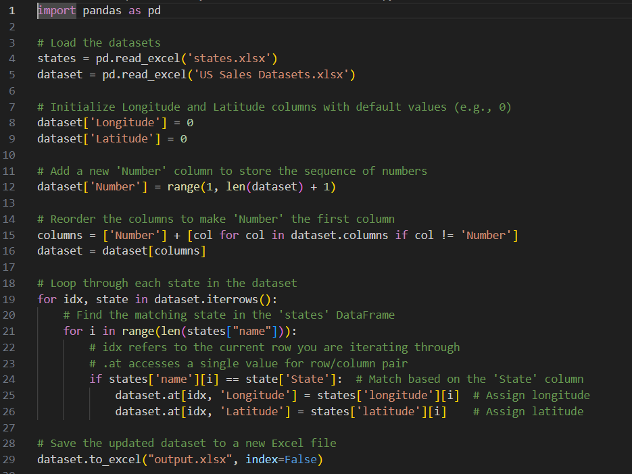

**Appendix 3:**

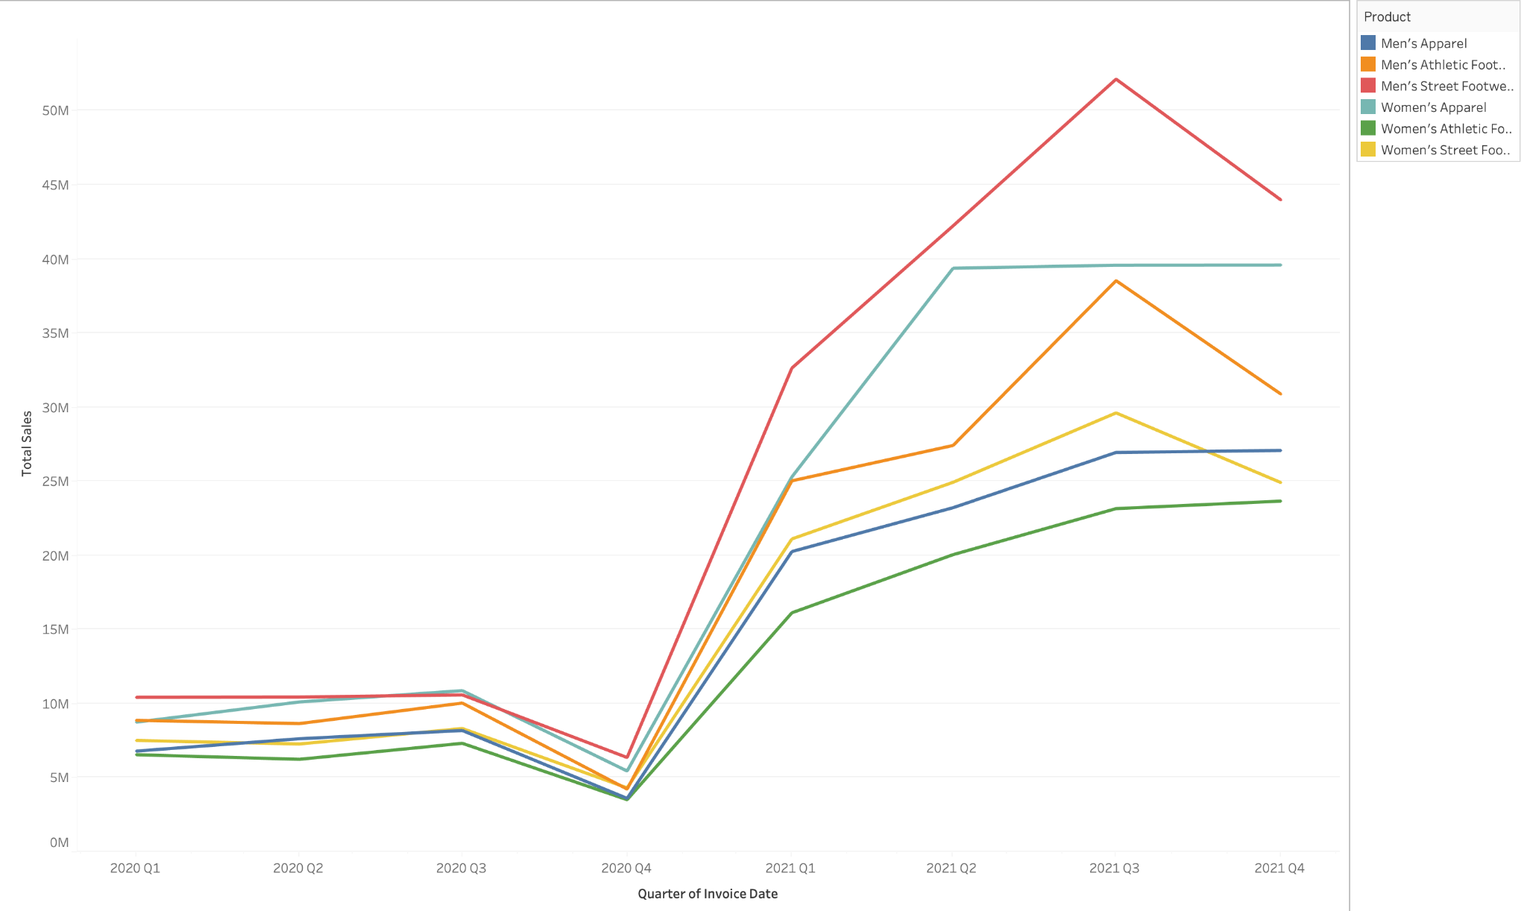

**Appendix 4:**

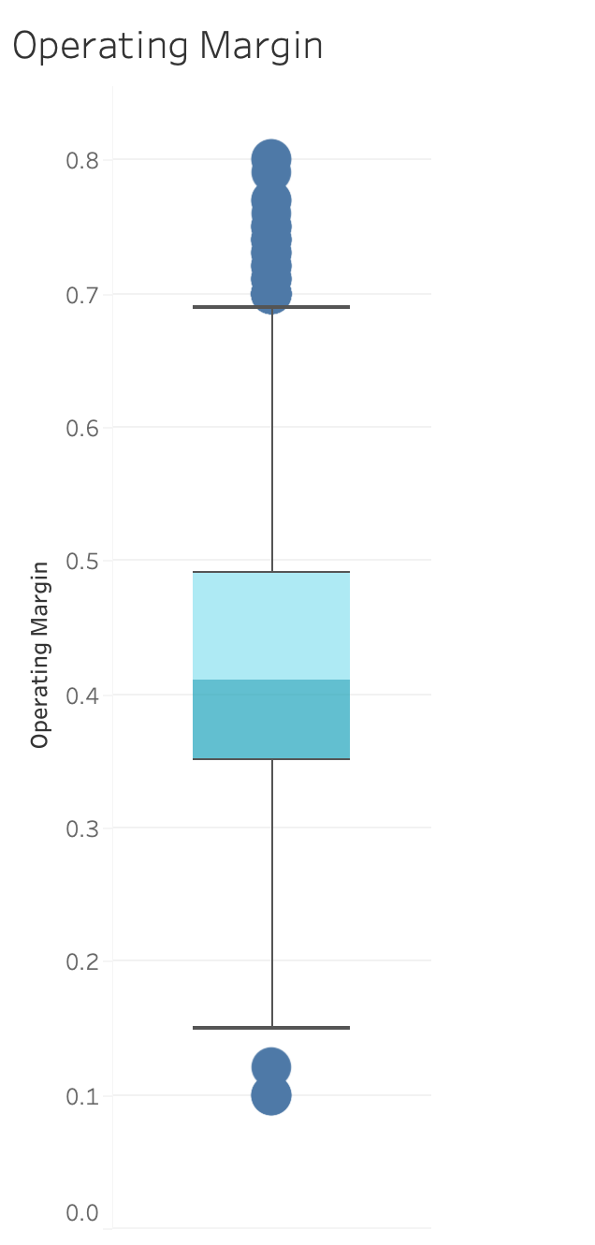

**Appendix 5:**

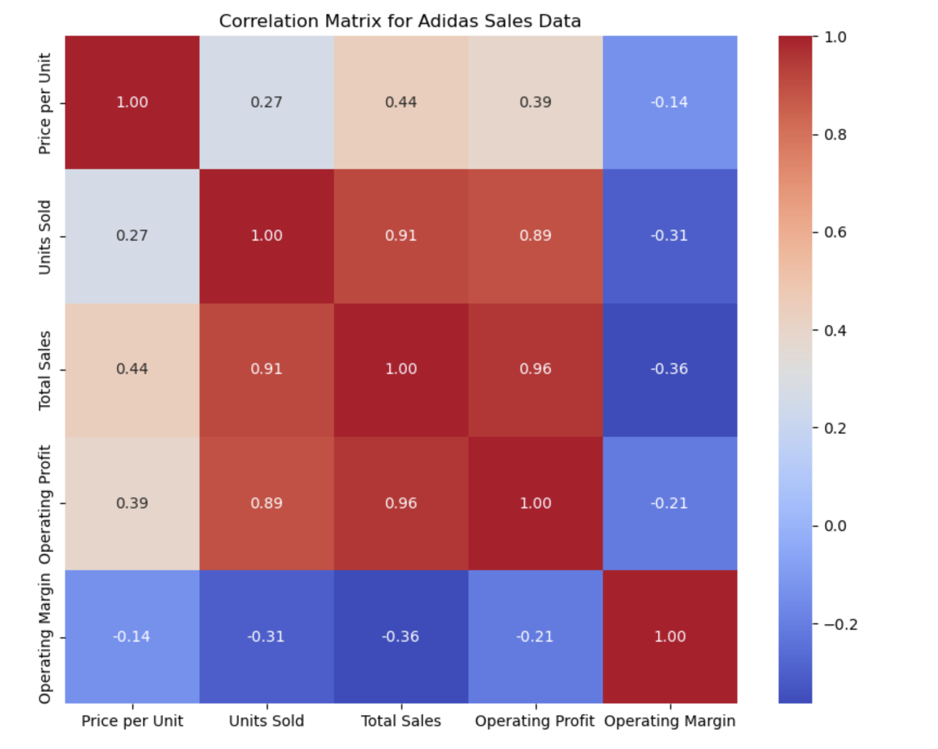

**Appendix 6:**

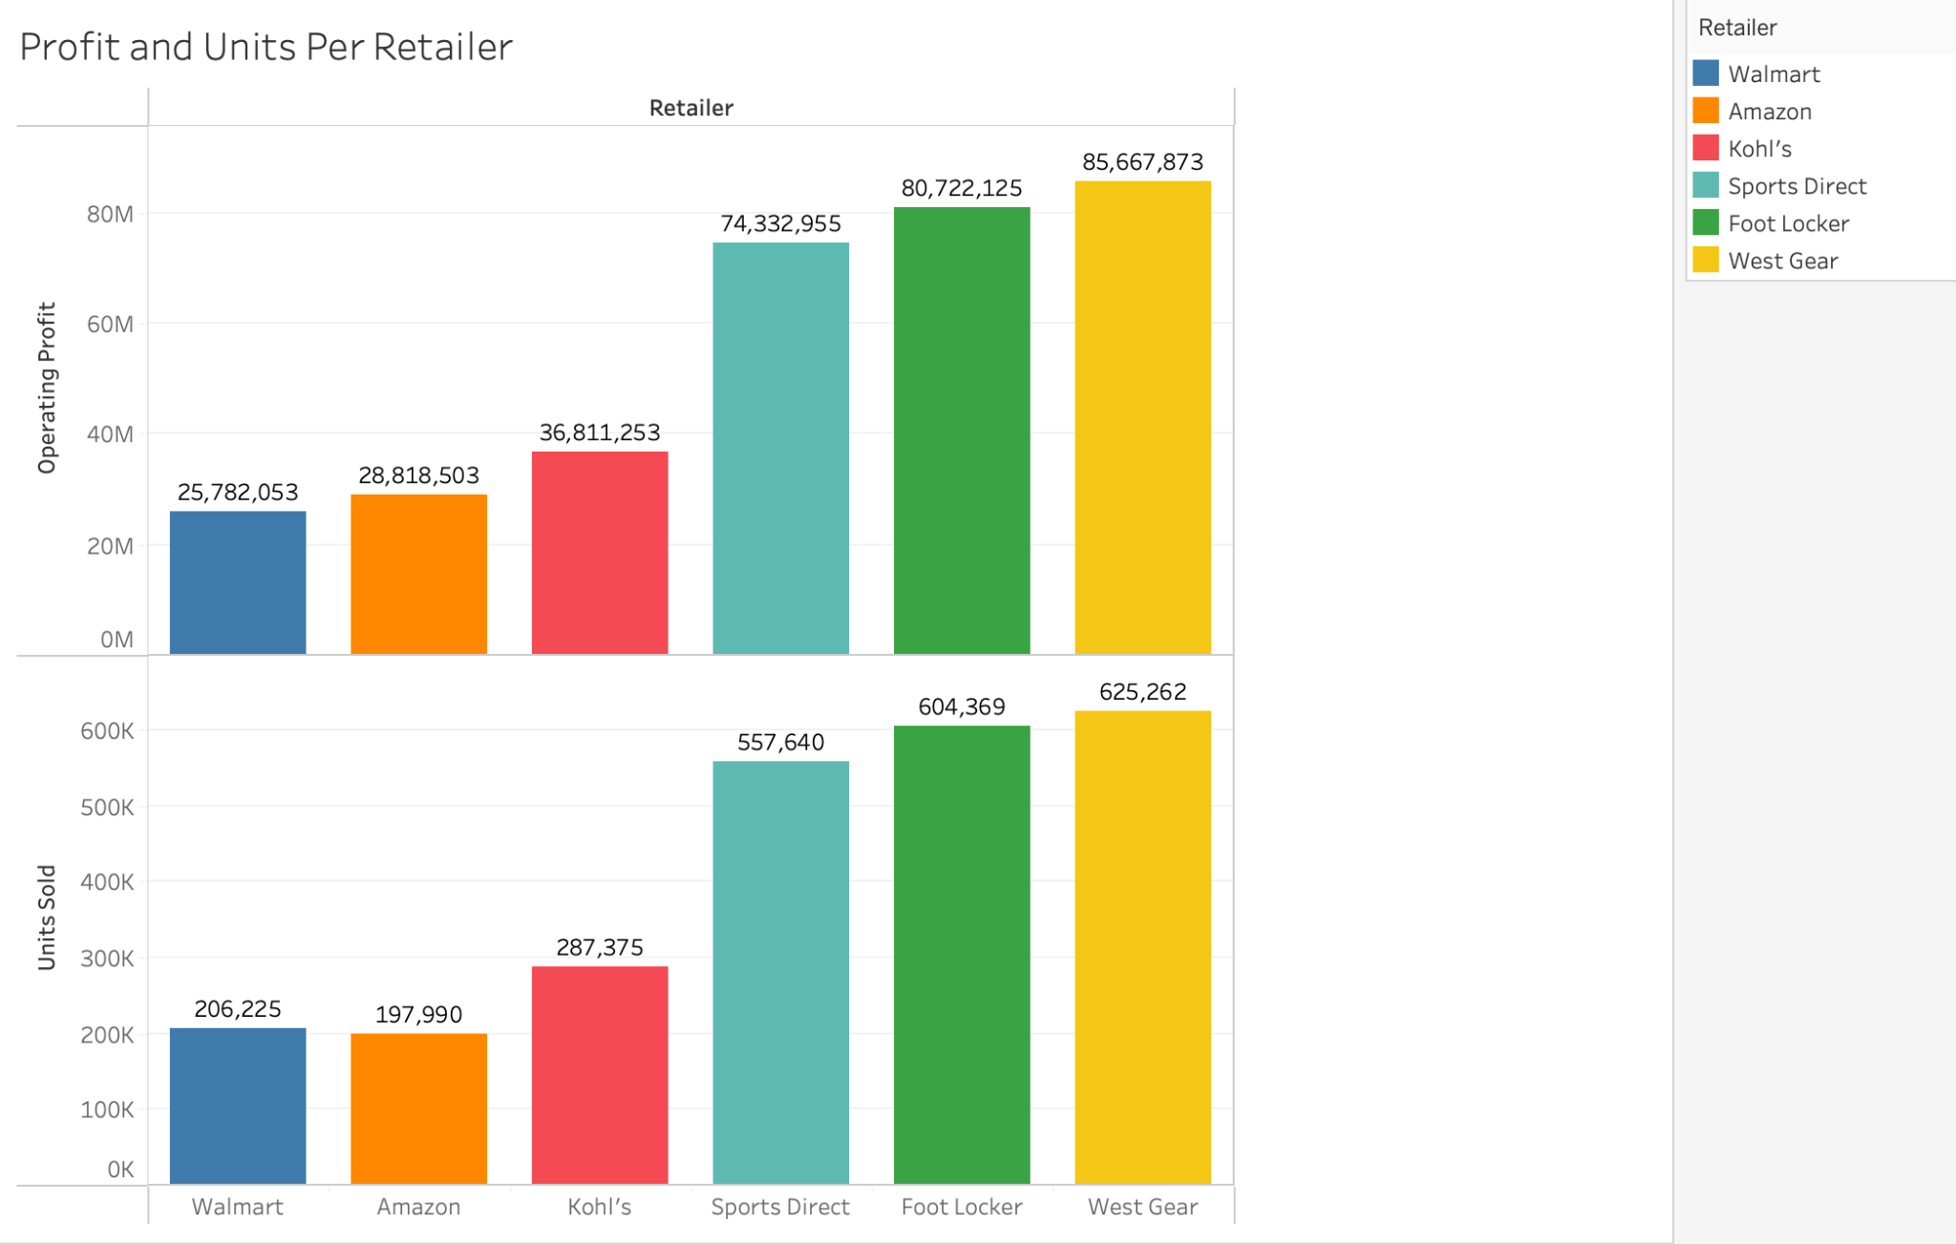

**Appendix 7:**

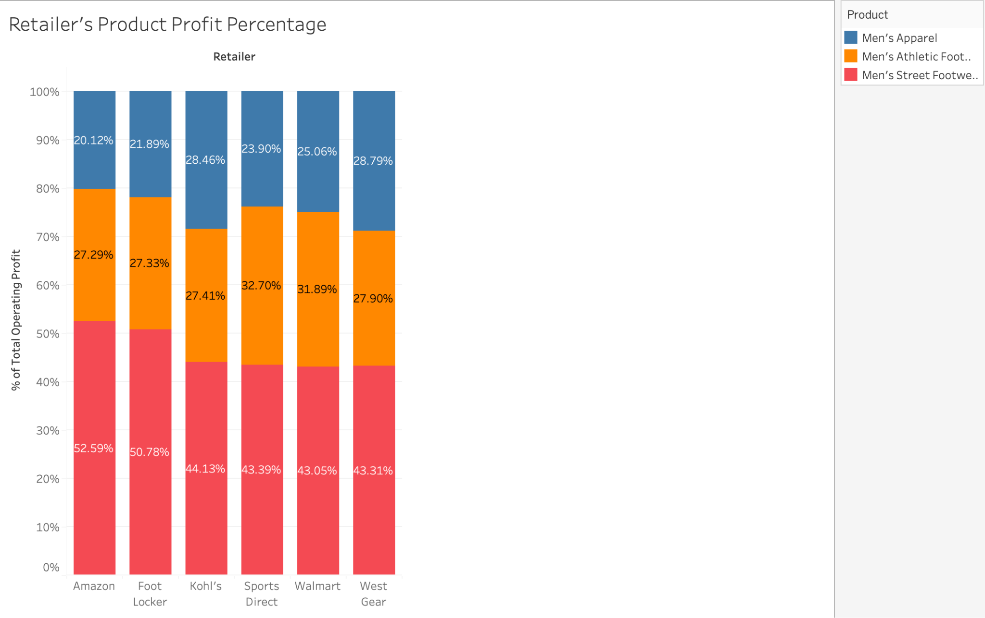

**Appendix 8:** 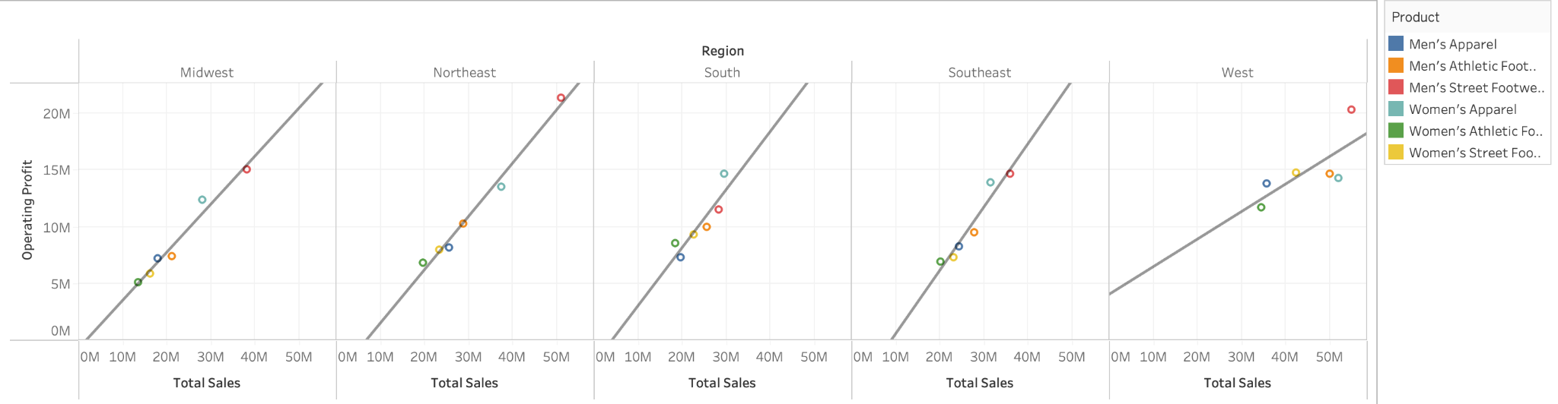

**Appendix 9:**

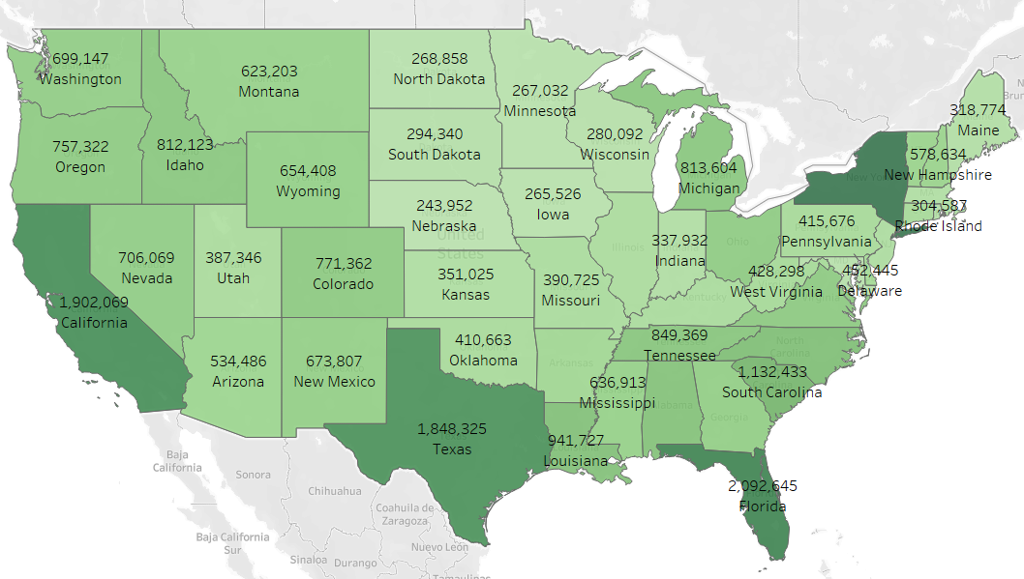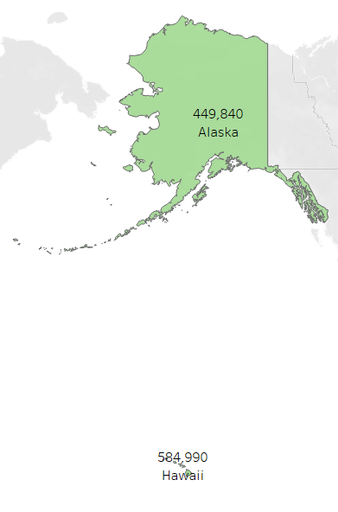

**Appendix 10:**

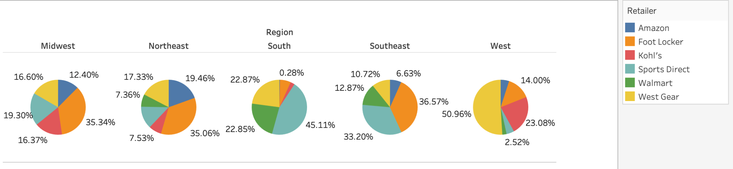

**References**

Abbas, A. (2023, September 4). *Adidas Sales*. Kaggle. https://www.kaggle.com/datasets/ahmedabbas757/dataset

*Apparel, footwear & accessories industry profitability*. Apparel, Footwear & Accessories Industry Profitability by quarter, Gross, Operating and Net Margin from 3 Q 2024. (n.d.). https://csimarket.com/Industry/industry_Profitability_Ratios.php?ind=401

Google. (n.d.). *DSPL/samples/google/canonical/states.csv at master · google/DSPL*. GitHub. https://github.com/google/dspl/blob/master/samples/google/canonical/states.csv

Herzogenaurach. (n.d.). *Adidas brand momentum drives double-digit top-line growth in the second quarter of 2024 - adidas group*. adidas. https://www.adidas-group.com/en/media/press-releases/adidas-brand-momentum-drives-double-digit-top-line-growth-in-the-second-quarter-of-2024

*History - adidas group*. adidas. (n.d.). https://www.adidas-group.com/en/about/history